 **Appendix 1**

**18/02211/FUL – 31A Charlbury Road**

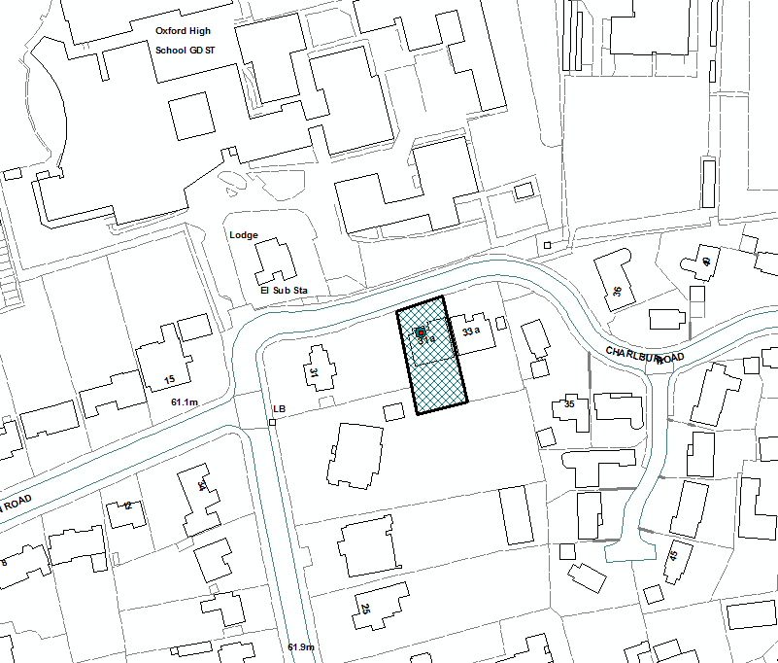

N